***Computation of LR(0) Items***

*Ayush Jindal*

*RA1911003010308*

***Aim:*** *To code a program that computes the LR(0) items for given grammar.*

***Algorithm:***

1. *Start.*
2. *Create structure for production with LHS and RHS. 3.Open file and read input from file.*
3. *Build state 0 from extra grammar Law S' -> S $ that is all start symbol of grammar and one Dot ( . ) before S symbol.*
4. *If Dot symbol is before a non-terminal, add grammar laws that this non- terminal is in Left 6.Hand Side of that Law and set Dot in before of first part of Right Hand Side.*

*7.If state exists (a state with this Laws and same Dot position), use that instead. 8.Now find set of terminals and non-terminals in which Dot exist in before.*

1. *If step 7 Set is non-empty go to 9, else go to 10.*
2. *For each terminal/non-terminal in set step 7 create new state by using all grammar law that*

*Dot position is before of that terminal/non-terminal in reference state by increasing Dot point*

*to next part in Right Hand Side of that laws. 11.Go to step 5.*

*12.End of state building. 13.Display the output.*

*14.End*

***Code:***

*#include<iostream>*

*#include<conio.h>*

*#include<string.h>*

*using namespace std;*

*char prod[20][20],listofvar[26]="ABCDEFGHIJKLMNOPQR"; int novar=1,i=0,j=0,k=0,n=0,m=0,arr[30];*

*int noitem=0;*

*struct Grammar*

*{*

*char lhs; char rhs[8];*

*}g[20],item[20],clos[20][10];*

*int isvariable(char variable)*

*{*

*for(int i=0;i<novar;i++)*

*if(g[i].lhs==variable)*

*return i+1;*

*return 0;*

*}*

*void findclosure(int z, char a)*

*{*

*int n=0,i=0,j=0,k=0,l=0; for(i=0;i<arr[z];i++)*

*{*

*for(j=0;j<strlen(clos[z][i].rhs);j++)*

*{*

*if(clos[z][i].rhs[j]=='.' && clos[z][i].rhs[j+1]==a)*

*{*

*clos[noitem][n].lhs=clos[z][i].lhs;*

*strcpy(clos[noitem][n].rhs,clos[z][i].rhs); char temp=clos[noitem][n].rhs[j];*

*clos[noitem][n].rhs[j]=clos[noitem][n].rhs[j+1]; clos[noitem][n].rhs[j+1]=temp;*

*n=n+1;*

*}*

*}*

*}*

*for(i=0;i<n;i++)*

*{*

*for(j=0;j<strlen(clos[noitem][i].rhs);j++)*

*{*

*if(clos[noitem][i].rhs[j]=='.' && isvariable(clos[noitem][i].rhs[j+1])>0)*

*{*

*for(k=0;k<novar;k++)*

*{*

*if(clos[noitem][i].rhs[j+1]==clos[0][k].lhs)*

*{*

*strcmp(clos[noitem][l].rhs,clos[0][k].rhs)==0)*

*for(l=0;l<n;l++)*

*if(clos[noitem][l].lhs==clos[0][k].lhs &&*

*break;*

*if(l==n)*

*{*

*clos[noitem][n].lhs=clos[0][k].lhs;*

*strcpy(clos[noitem][n].rhs,clos[0][k].rhs); n=n+1;*

*}*

*}*

*}*

*}*

*}*

*}*

*arr[noitem]=n; int flag=0;*

*for(i=0;i<noitem;i++)*

*{*

*if(arr[i]==n)*

*{*

*for(j=0;j<arr[i];j++)*

*{*

*int c=0; for(k=0;k<arr[i];k++)*

*if(clos[noitem][k].lhs==clos[i][k].lhs && strcmp(clos[noitem][k].rhs,clos[i][k].rhs)==0)*

*if(c==arr[i])*

*{*

*c=c+1;*

*}*

*}*

*exit:;*

*flag=1; goto exit;*

*}*

*}*

*if(flag==0)*

*arr[noitem++]=n;*

*}*

*int main()*

*{*

*cout<<"ENTER THE PRODUCTIONS OF THE GRAMMAR(0 TO END) :\n";*

*do*

*{*

*cin>>prod[i++];*

*}while(strcmp(prod[i-1],"0")!=0); for(n=0;n<i-1;n++)*

*{*

*m=0;*

*j=novar; g[novar++].lhs=prod[n][0]; for(k=3;k<strlen(prod[n]);k++)*

*{*

*if(prod[n][k] != '|')*

*g[j].rhs[m++]=prod[n][k];*

*if(prod[n][k]=='|')*

*{*

*g[j].rhs[m]='\0'; m=0;*

*j=novar; g[novar++].lhs=prod[n][0];*

*}*

*}*

*}*

*for(i=0;i<26;i++)*

*if(!isvariable(listofvar[i]))*

*break; g[0].lhs=listofvar[i];*

*char temp[2]={g[1].lhs,'\0'}; strcat(g[0].rhs,temp);*

*cout<<"\n\n augumented grammar \n"; for(i=0;i<novar;i++)*

*cout<<endl<<g[i].lhs<<"->"<<g[i].rhs<<" ";*

*for(i=0;i<novar;i++)*

*{*

*clos[noitem][i].lhs=g[i].lhs;*

*strcpy(clos[noitem][i].rhs,g[i].rhs);*

*if(strcmp(clos[noitem][i].rhs,"ε")==0)*

*strcpy(clos[noitem][i].rhs,".");*

*else*

*{*

*}*

*}*

*for(int j=strlen(clos[noitem][i].rhs)+1;j>=0;j--) clos[noitem][i].rhs[j]=clos[noitem][i].rhs[j-1];*

*clos[noitem][i].rhs[0]='.';*

*arr[noitem++]=novar; for(int z=0;z<noitem;z++)*

*{*

*char list[10]; int l=0;*

*for(j=0;j<arr[z];j++)*

*{*

*for(k=0;k<strlen(clos[z][j].rhs)-1;k++)*

*{*

*if(clos[z][j].rhs[k]=='.')*

*{*

*for(m=0;m<l;m++)*

*if(list[m]==clos[z][j].rhs[k+1]) break;*

*if(m==l)*

*}*

*}*

*}*

*list[l++]=clos[z][j].rhs[k+1];*

*for(int x=0;x<l;x++)*

*findclosure(z,list[x]);*

*}*

*cout<<"\n THE SET OF ITEMS ARE \n\n"; for(int z=0; z<noitem; z++)*

*{*

*cout<<"\n I"<<z<<"\n\n"; for(j=0;j<arr[z];j++)*

*cout<<clos[z][j].lhs<<"->"<<clos[z][j].rhs<<"\n";*

*}*

*}*

***Output:***

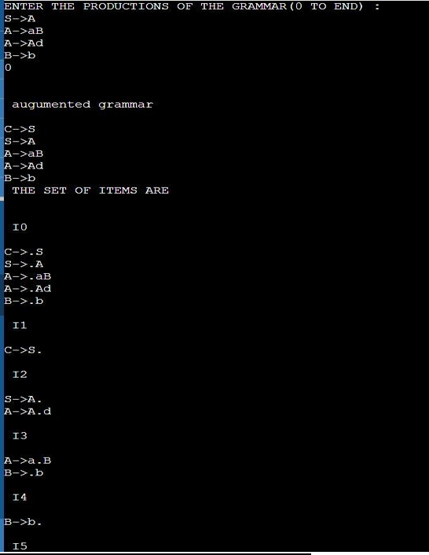

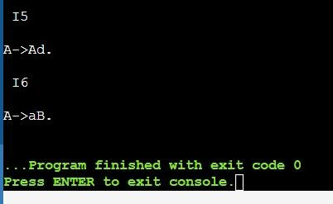

***Manual calculation:***

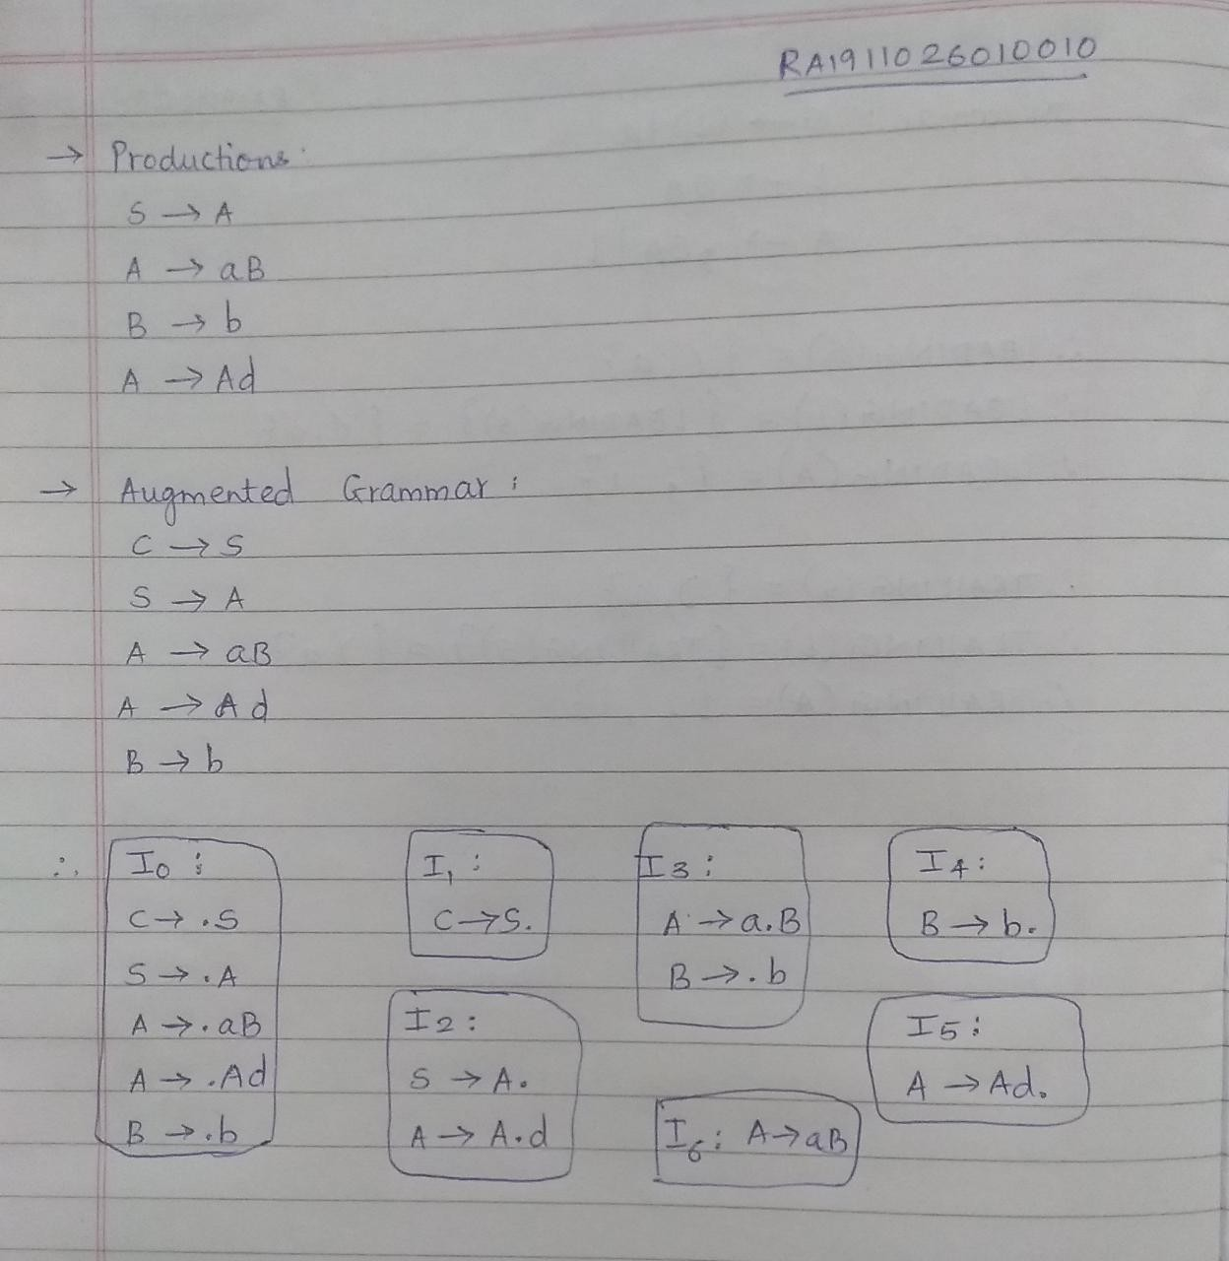

*Thus, the manual calculation matches the output successfully.*

***Result****: Thus, we implemented a program that computes the LR(0) items for given grammar.*